1. Установка meta-toolchain-qt5

./poky-glibc-x86_64-meta-toolchain-qt5-cortexa7t2hf-neon-vfpv4-raspberrypi-cm3-toolchain-2.7.1.sh

выбрать директорию для установки (по умолчанию /opt/poky/2.7.1)

/opt/poky/cm3/2.7.1

2. Настройка Qt Creator

В редакторе Tools | Options

Добавить Qt version
- Version name: Qt %{Qt:Version} (Raspberry Pi CM3)
- qmake location: /opt/poky/cm3/2.7.1/sysroots/x86_64-pokysdk-linux/usr/bin/qmake
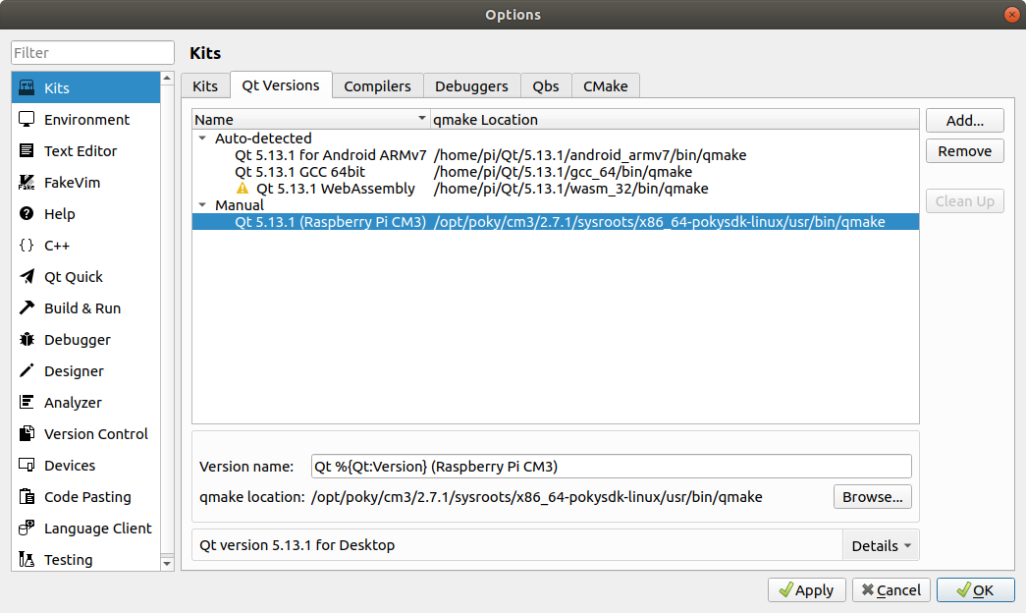

Добавить Compilers

- Name: GCC for Raspberry Pi CM3
- Compiler path: /opt/poky/cm3/2.7.1/sysroots/x86_64-pokysdk-linux/usr/bin/arm-poky-linux-gnueabi/arm-poky-linux-gnueabi-gcc
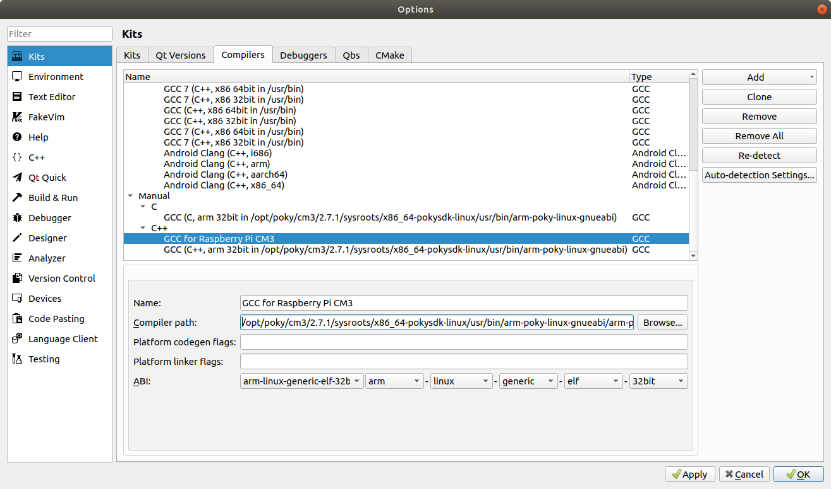

Добавить Debuggers

- Name: GDB for Raspberry Pi CM3
- Path: /opt/poky/cm3/2.7.1/sysroots/x86_64-pokysdk-linux/usr/bin/arm-poky-linux-gnueabi/arm-poky-linux-gnueabi-gdb

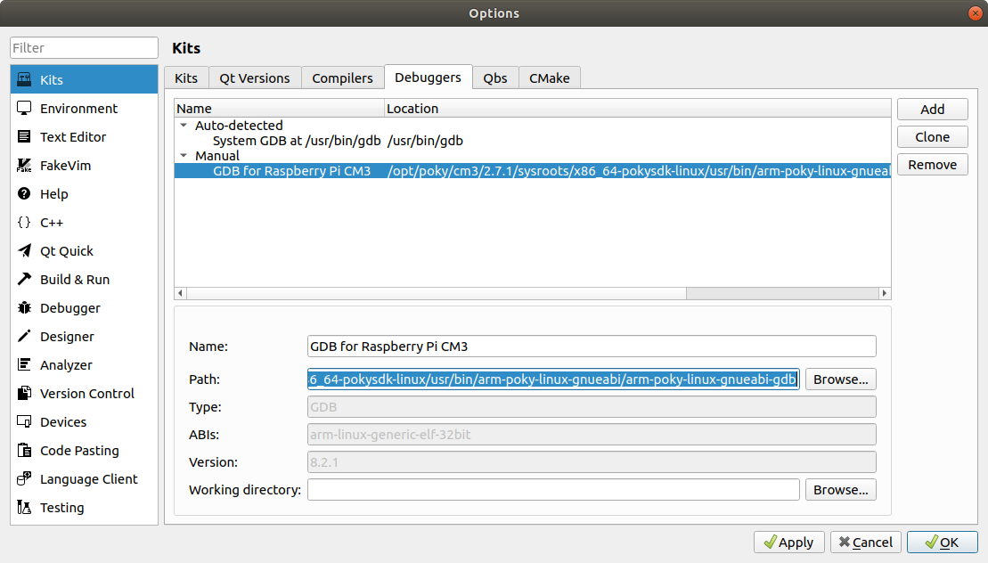

Добавить Kits

- Name: Qt %{Qt:Version} for Raspberry Pi CM3
- Device type: Generic Linux Device
- Device: Raspberry pi cm3 (default for Generic Linux)
- Sysroot: /opt/poky/cm3/2.7.1/sysroots/x86_64-pokysdk-linux/usr/bin/arm-poky-linux-gnueabi
- Compiler: GCC for Raspberry Pi CM3
- Environment: No changes to apply.
- Debugger: GDB for Raspberry Pi CM3
- Qt version: RPi 5.7
- Qt mkspec: linux-oe-g++
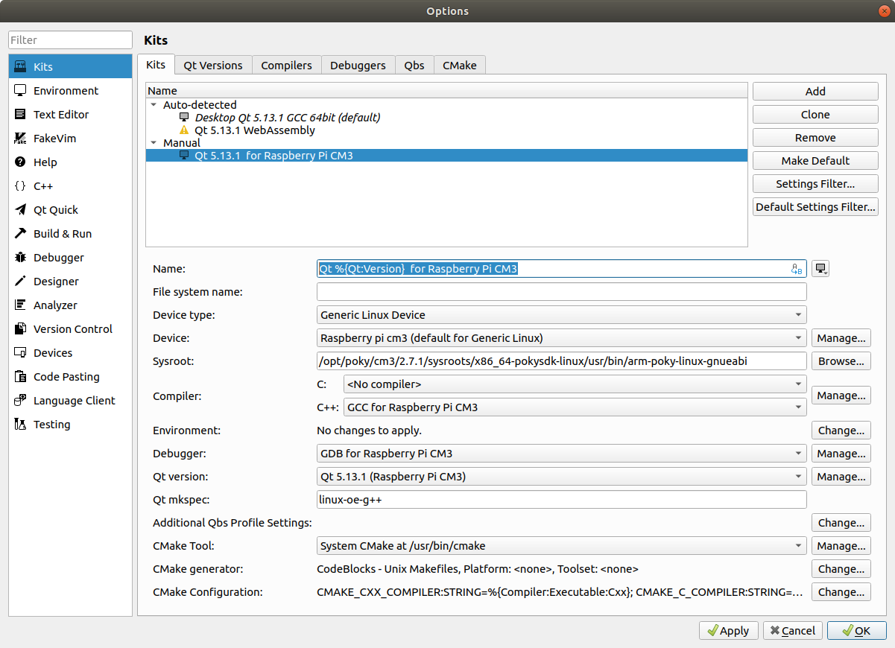
Настройка Devices

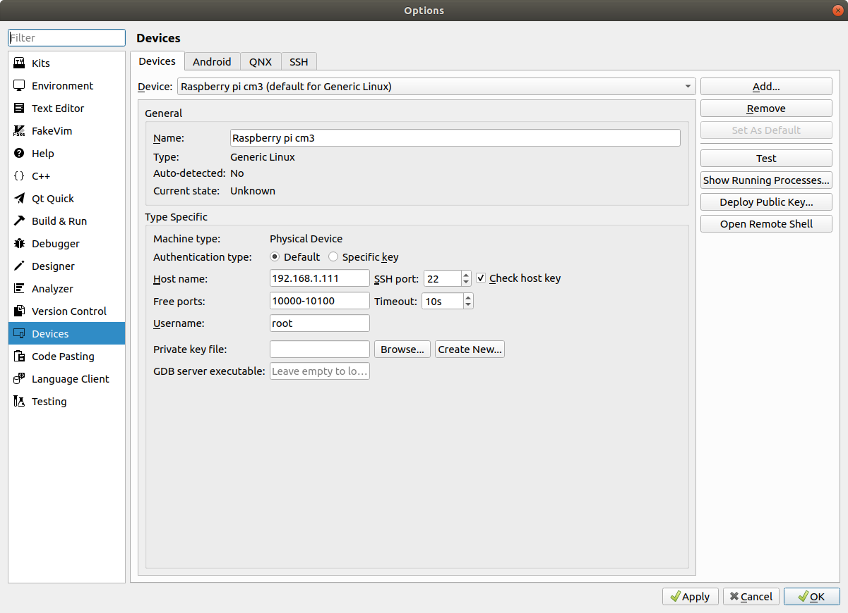
Запуск

source /opt/poky/cm3/2.7.1/environment-setup-cortexa7t2hf-neon-vfpv4-poky-linux-gnueabi

~/Qt/Tools/QtCreator/bin/qtcreator

